Задание 1.

Docker-compose — это надстройка над докером, предназначена для решения задач, связанных с развертыванием проектов. Технология Docker Compose, если описывать её упрощённо, позволяет, с помощью одной команды, запускать множество сервисов, чем мы сейчас и займемся)

Задание 2.

version: "3"

services:

networks:

volkovsa-my-netology-hw:

driver: bridge

ipam:

config:

- subnet: 172.22.0.0/24

Задание 3.

netology-db:

image: postgres:latest

container_name: volkovsa-netology-db

ports:

- 5432:5432

volumes:

- ./pg_data:/var/lib/postgresql/data/pgdata

environment:

POSTGRES_PASSWORD: 123

POSTGRES_DB: volkovsa_db

PGDATA: /var/lib/postgresql/data/pgdata

networks:

volkovsa-my-netology-hw:

ipv4_address: 172.22.0.2

restart: always

Задание 4.

pgadmin:

image: dpage/pgadmin4

depends_on:

- netology-db

container_name: volkovsa-pgadmin

environment:

PGADMIN_DEFAULT_EMAIL: volkovsa@mymail.me

PGADMIN_DEFAULT_PASSWORD: 123

ports:

- "61231:80"

networks:

volkovsa-my-netology-hw:

ipv4_address: 172.22.0.3

restart: always

Задание 5.

zabbix-server:

image: zabbix/zabbix-server-pgsql

links:

- netology-db

container_name: volkovsa-zabbix-netology

environment:

DB_SERVER_HOST: '172.22.0.2'

POSTGRES_USER: "postgres"

POSTGRES_PASSWORD: "123"

ports:

- "10051:10051"

networks:

volkovsa-my-netology-hw:

ipv4_address: 172.22.0.4

restart: always

Задание 6.

zabbix_wgui:

image: zabbix/zabbix-web-apache-pgsql

links:

- netology-db

- zabbix-server

container_name: volkovsa-netology-zabbix-frontend

environment:

DB_SERVER_HOST: '172.22.0.2'

POSTGRES_USER: "postgres"

POSTGRES_PASSWORD: "123"

ZBX_SERVER_HOST: "zabbix_wgui"

PHP_TZ: "Europe/Moscow"

ports:

- "80:8080"

- "443:8443"

networks:

volkovsa-my-netology-hw:

ipv4_address: 172.22.0.5

restart: always

Задание 7.

version: "3"

services:

netology-db:

image: postgres:latest

container_name: volkovsa-netology-db

ports:

- 5432:5432

volumes:

- ./pg_data:/var/lib/postgresql/data/pgdata

environment:

POSTGRES_PASSWORD: 123

POSTGRES_DB: volkovsa_db

PGDATA: /var/lib/postgresql/data/pgdata

networks:

volkovsa-my-netology-hw:

ipv4_address: 172.22.0.2

restart: always

pgadmin:

image: dpage/pgadmin4

depends_on:

- netology-db

container_name: volkovsa-pgadmin

environment:

PGADMIN_DEFAULT_EMAIL: volkovsa@mymail.me

PGADMIN_DEFAULT_PASSWORD: 123

ports:

- "61231:80"

networks:

volkovsa-my-netology-hw:

ipv4_address: 172.22.0.3

restart: always

zabbix-server:

image: zabbix/zabbix-server-pgsql

links:

- netology-db

container_name: volkovsa-zabbix-netology

environment:

DB_SERVER_HOST: '172.22.0.2'

POSTGRES_USER: "postgres"

POSTGRES_PASSWORD: "123"

ports:

- "10051:10051"

networks:

volkovsa-my-netology-hw:

ipv4_address: 172.22.0.4

restart: always

zabbix_wgui:

image: zabbix/zabbix-web-apache-pgsql

links:

- netology-db

- zabbix-server

container_name: volkovsa-netology-zabbix-frontend

environment:

DB_SERVER_HOST: '172.22.0.2'

POSTGRES_USER: "postgres"

POSTGRES_PASSWORD: "123"

ZBX_SERVER_HOST: "zabbix_wgui"

PHP_TZ: "Europe/Moscow"

ports:

- "80:8080"

- "443:8443"

networks:

volkovsa-my-netology-hw:

ipv4_address: 172.22.0.5

restart: always

networks:

volkovsa-my-netology-hw:

driver: bridge

ipam:

config:

- subnet: 172.22.0.0/24

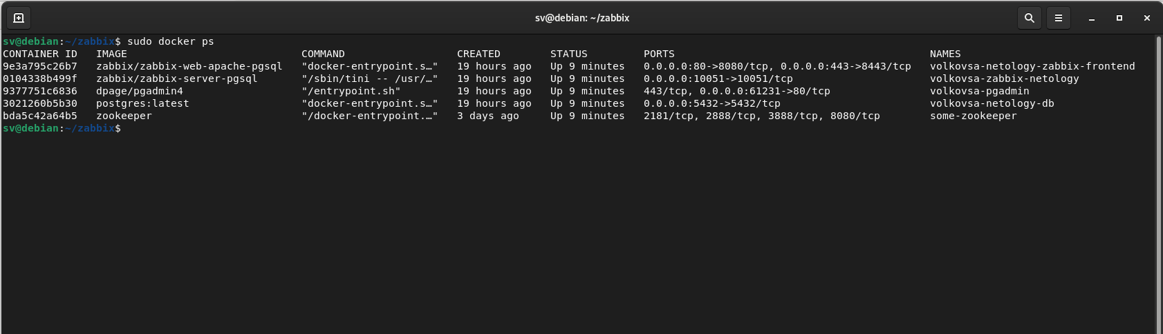

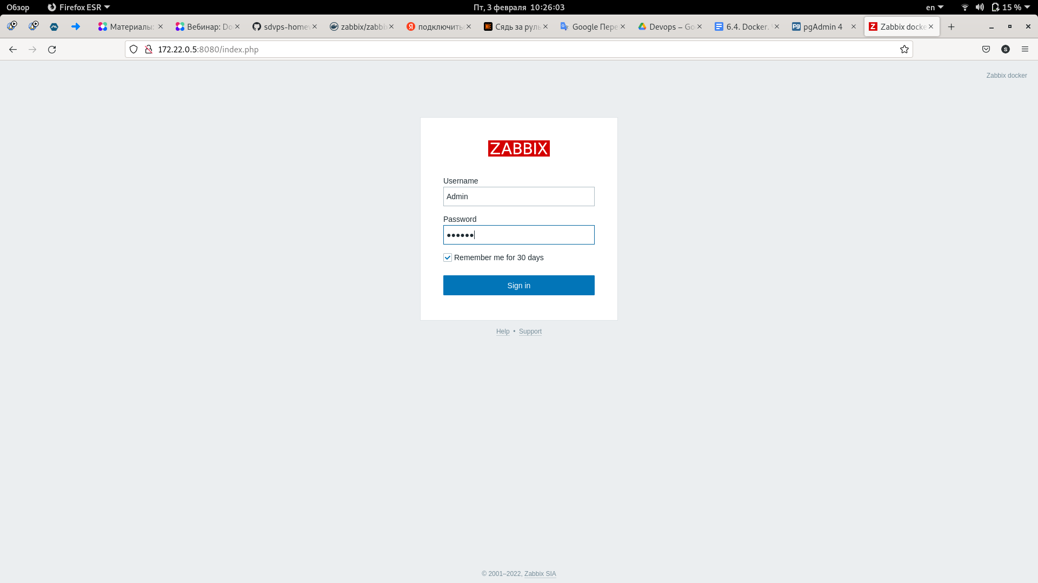

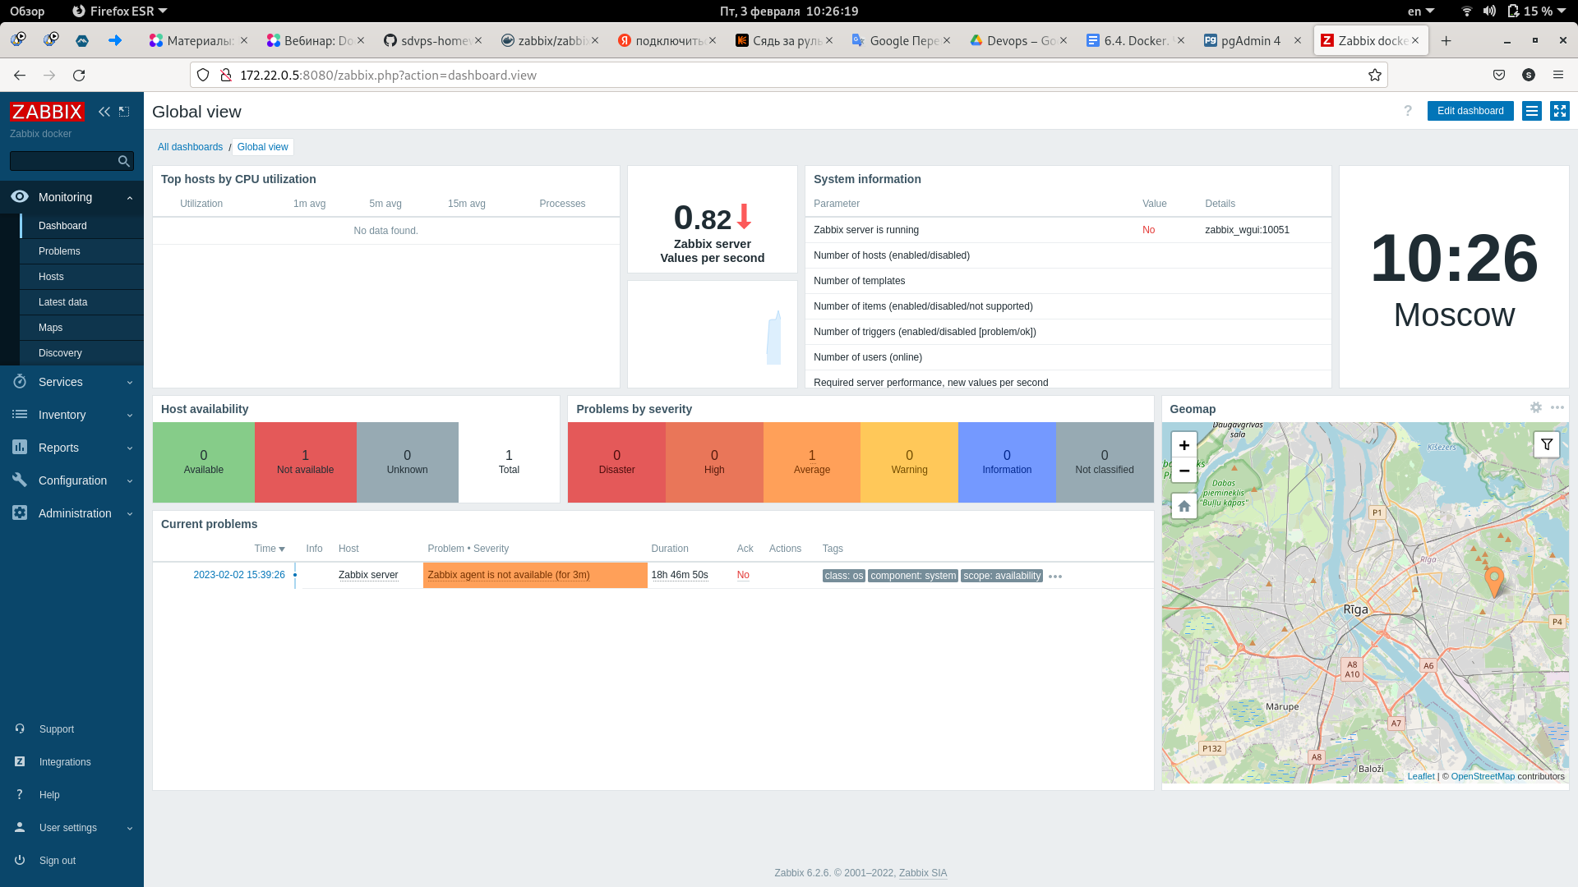

Задание 8.

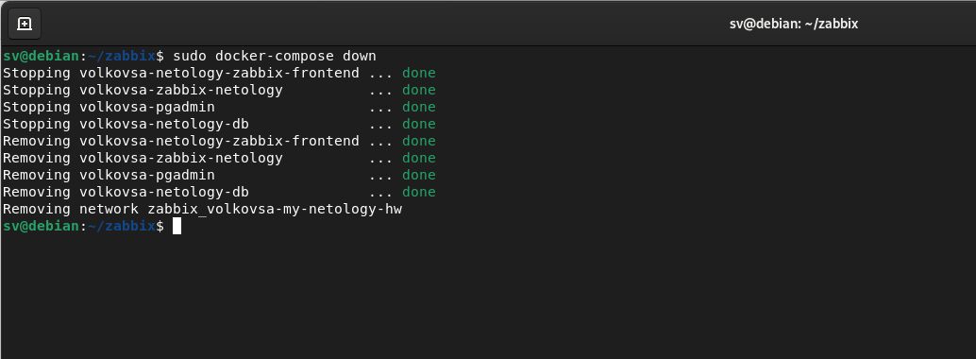

Задание 9*.